ZONAL COMPETITIONS
- Mudit Gupta of Class XII B and Aarav of Class VIII D participated in Zonal Monoacting Competition on 31 July, 2018. Mudit Bagged First Prize in Senior Category and Aarav bagged Second Prize in Junior Category.
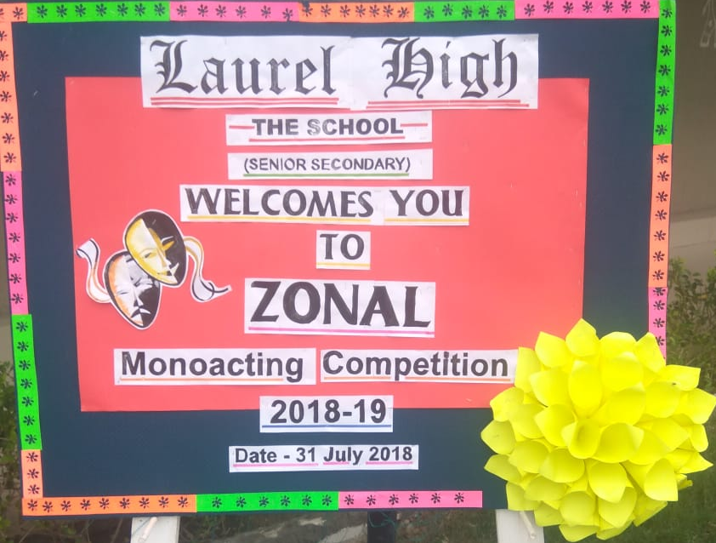
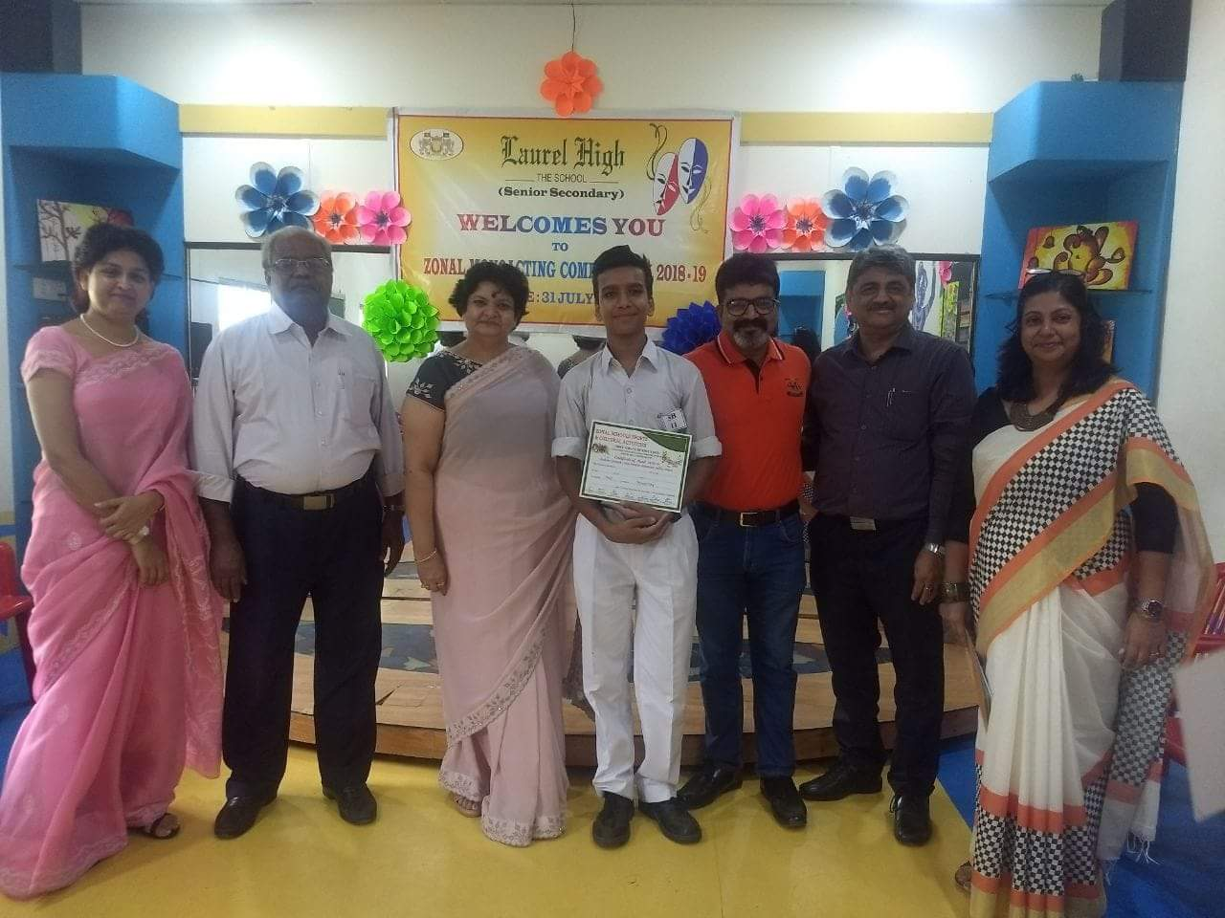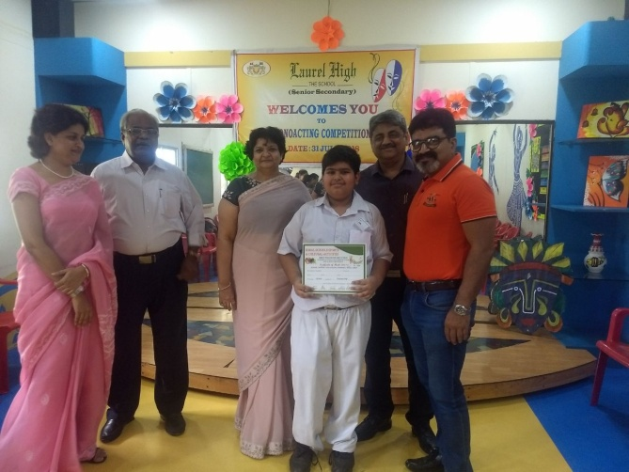

- Sakshi Prakash of Class X C got Ist prize in Classical Vocal in Zonal Competition



