NCO(National Cyber Olympiad) Result

Class 3 Toppers
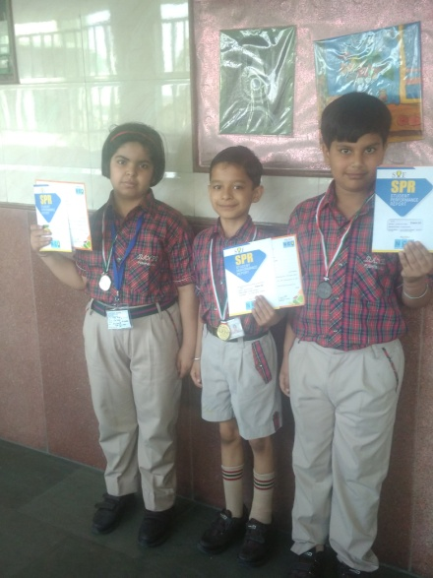
Student's name | Rank Holder
NITANSH AGGARWAL | I (Gold Medal)
SHHARVY JUNEJA | II (Silver Medal)
VIVAAN RAWAL | III ( Bronze Medal)
Class 5 Topper
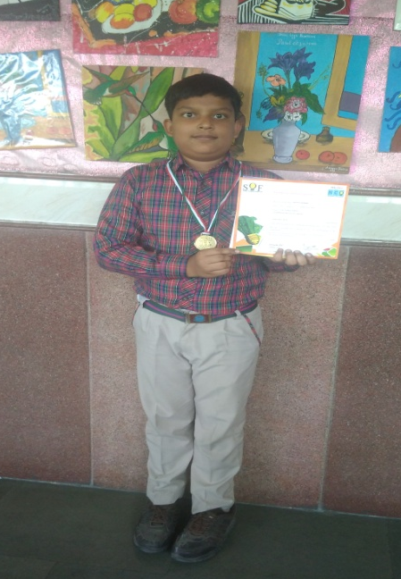
Student's name | Rank Holder
ANUNOY SHARMA | I (Zonal Gold Medal)+ Rs.5000/-+  Certificate of Zonal Excellence
Class 7 Toppers
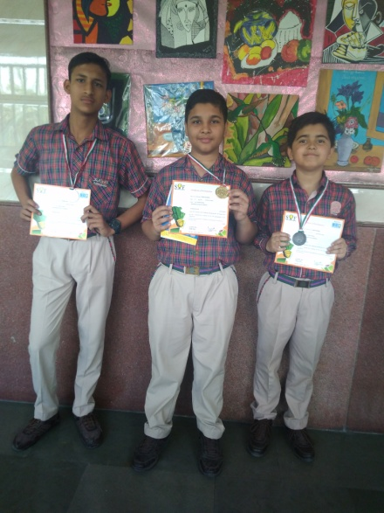
Student's name | Rank Holder
TANISH AGARWAL | I (Gold Medal)
HARSH GARG | II (Silver Medal)
DAKSH SHARMA | III ( Bronze Medal)
Class 8 Toppers
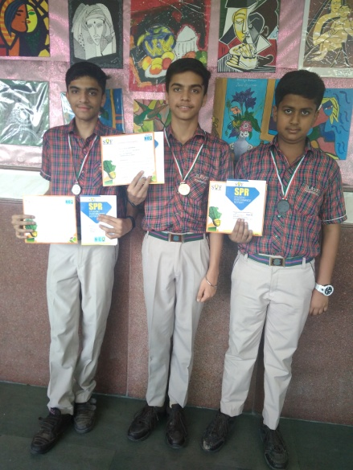
Student's name | Rank Holder
ADITYA BHATIA | I (Gold Medal)
SHIV SHARMA | II (Silver Medal)
ASHISH DRAVERIYA | III ( Bronze Medal)

